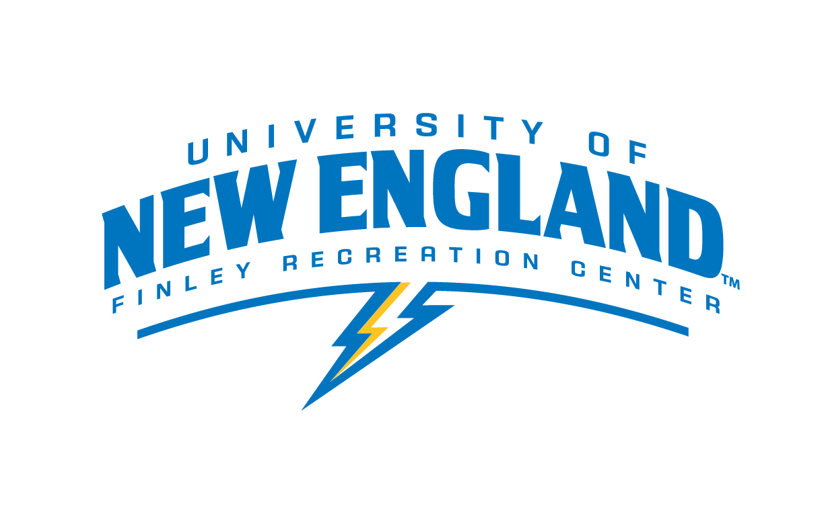

Intramural Coordinator

Department: Finley Recreation Center
Purpose: Be a representative of the Intramural Program at the Finley Recreation Center
Pay Rate: $12.00
Schedule: To be determined by staff availability – Hours are 6am to 10pm Monday through Friday, 8am to 8pm on weekends and are subject to change.

Job Responsibilities:

- To be a positive representative of the Intramural Program at the Finley Recreation Center and act as a liaison with those who participate.
- Responsible for assigned supervision of intramural games and special events.
- Responsible for attending all staff meetings and training sessions.
- Directly responsible for preparing facility and or fields for activities, including facility safety checks and equipment set-up and breakdown.
- Directly responsible for games and contests starting on time and co-refereeing
- Directly responsible for representing the Intramural policies and procedures when there is a dispute at the playing site.
- Responsible for taking appropriate actions when dealing with patrons who are causing disturbances or persist in violating expressed policies and procedures.
- Must be able to consult with the Finley Recreation Center’s professional staff on all matters.
- Consistently work to maintain a safe environment for participants of the program.
- Responsible for assisting with marketing strategies for the respective intramural sport, such as formatting marketing emails and promotional flyers.
- Responsible for setting up registrations, collecting and filing waivers, team rosters, and game brackets through IMleagues.com.
- Make operational decisions based on established policies and procedures using sound judgment.
- Submit one social media post per week, i.e. picture or video of game, team photo
- Responsible for performing other duties as assigned by the Finley Recreation Center’s professional staff.

Job Requirements and/or Qualifications:

- Prior experience with an intramural sports program preferred.
- Proven dependability and availability to work evenings and weekends.
- Ability to communicate effectively with participants and staff.
- Demonstrated ability to explain and enforce departmental and intramural policies and procedures.
- Must possess outstanding leadership skills and customer service skills.
- Must be a team player and willing to work as a committed member in the intramural sports program.
- Possesses a desire to work for the program and demonstrates initiative.
- Must be knowledgeable or have the ability to gain knowledge in all sport rules offered by the intramural sports program.
- Must be familiar with IMleagues.com and/or show a desire to learn.
- CPR Certification and First Aid Certification required (can obtain after getting hired).

Employment Agreement:

As a representative of UNE, you are expected to be a role model, exhibiting appropriate behavior at all times. Violations of the University Conduct Code may either prevent your selection for this position or terminate your employment.

The above job description has been fully explained to me by my immediate supervisor. I understand that I will be part of Finley Recreation Center Employment team. I understand the duties as outlined and agree to carry out these responsibilities upon acceptance of this position.

I understand that I if I breach any of the expectations above, I will undergo a “three strike” discipline system that includes the following steps if behavior does not improve:
· A verbal warning and meeting with my lead or staff supervisor(s)
· A written warning and meeting with my lead or staff supervisor(s)
· Termination of employment

Student’s Signature: __________________________________________Date: _________

I have thoroughly discussed the job description and expectations of this position with the student employee whose signature appears above. I agree to provide the training necessary to carry out the above functions successfully.

Supervisor’s Signature: ________________________________________Date: ________

Supervisor(s): Colleen Lundgren, CSCS, CPT, WFR
Email: clundgren@une.edu Phone: 207-221-4556

Supervisor(s): Judy Vezina
Email: jvezina@une.edu Phone: 207-221-4348

