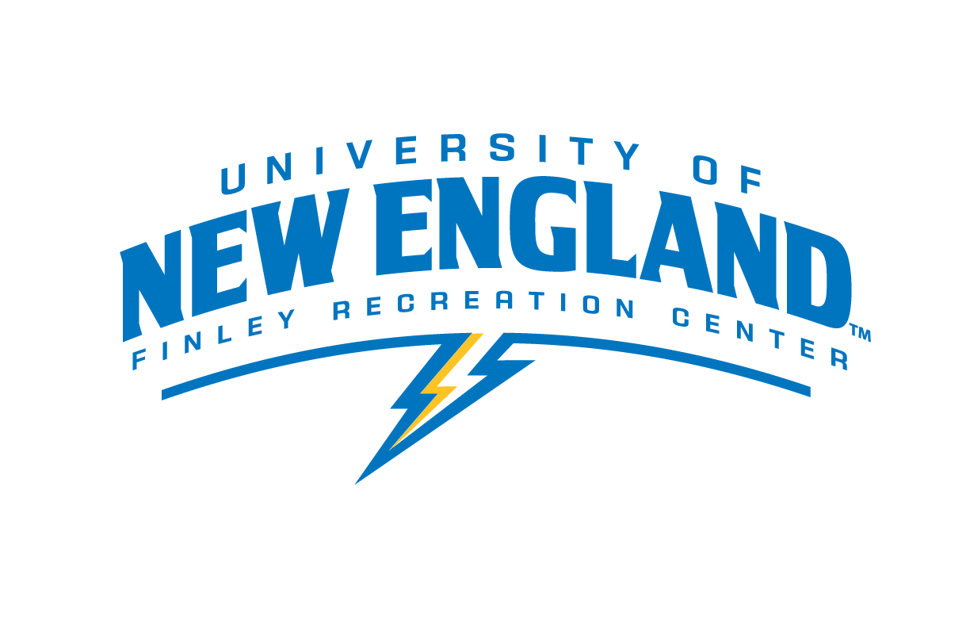

Social Media Specialist

Department: Finley Recreation Center
Purpose: To keep Finley Rec’s social media outlets up to date
Pay Rate: $11.00
Schedule: Negotiable

Job Responsibilities:

- Maintain Finley Rec’s social media outlets (Facebook, Instagram, Twitter, etc)
- Post photos, videos, etc. to social media of Finley events, students, etc.
- Share researched, quality information on health and wellness topics
- Advertise Finley Rec’s upcoming events on social media
- Post once daily on each social media outlet
- Attend one-on-one training sessions and meetings as needed

Job Requirements and/or Qualifications:

- Applicants will be selected based on the following criteria:
  - A desire to work with pictures/video editing, social media
  - Effective written communication skills
  - Trustworthiness
- Prior work experience in the Finley Recreation Center or some college level leadership position preferred
- Must be skilled in social media and video/picture sharing
- Attention to detail

Employment Agreement:

As a representative of UNE, you are expected to be a role model, exhibiting appropriate behavior at all times. Violations of the University Conduct Code may either prevent your selection for this position or terminate your employment.

The above job description has been fully explained to me by my immediate supervisor. I understand that I will be part of Finley Recreation Center Employment team. I understand the duties as outlined and agree to carry out these responsibilities upon acceptance of this position.

I understand that I if I breach any of the expectations above, I will undergo a “three strike” discipline system that includes the following steps if behavior does not improve:
· A verbal warning and meeting with my lead or staff supervisor(s)
· A written warning and meeting with my lead or staff supervisor(s)
· Termination of employment

Student’s Signature: __________________________________________Date: _________

I have thoroughly discussed the job description and expectations of this position with the student employee whose signature appears above. I agree to provide the training necessary to carry out the above functions successfully.

Supervisor’s Signature: ________________________________________Date: ________

Supervisor(s): Colleen Lundgren, CSCS, CPT, WFR
Email: clundgren@une.edu Phone: 207-221-4556

Supervisor(s): Judy Vezina
Email: jvezina@une.edu Phone: 207-221-4348

