U-ExCEL Workout of the Week #9
Strength & Balance, Circuit, Fusion

- Squat w/ Calf Raise
- Lateral Raise + Front Raise Hold
- Jog/Sprint
- Reverse Lunge w/ Knee Raise
- Plank Jack + Push-Up
- Deadlift + Alternating Front Raise
- Wall Sit + Bicep Curl
- Mummy Kicks
- Lateral Leg Raise Balance Hold
- Single Leg Balance Knee to Chest
Warm-Up: Butt kicks, Reach one arm up and across, Heel to toe taps, Hip circles, Shoulder Rolls, Leg swings, Wrist circles, or any creative way to get your body warmed up!



Sit & Fit

- Opposite Hand to Foot Leg Raise
- Elbow Press
- Seated Skaters
- Hammer Curl + Overhead Press
- Sit to Stands
- Opposite Elbow to Knee + Knee Tuck
- Chair Driving
- Side Bend Reach
- Back Leg Raises
- Single Leg Balance + Arm Circles (opposite hand + foot)

Ways to Mix up Your Weekly Workout Routine

Each class will have 10 exercises listed for the whole week. Switch up your routine daily with the examples below to prevent boredom:

Day 1: Repetitions (between 10-15 repetitions for each exercise depending on your comfort level)
Day 2: Time - 1 Minute for each exercise (repeat 2x for a longer workout)
Day 3: Circuit (4x 30 seconds for each exercise)
Day 4: Word Search Workout (see attached PDF)
Day 5: TABATA Workout (6 Rounds, 20 seconds on, 10 seconds rest)

Core Dynamics

- Pelvic Tilts
- Single Leg Raise + Toe Touch
- Clam Shells
- Single Leg Hip Bridges
- Knee Sliders
- Lying Windshield Wipers
- Heel to Toe Upper Ab Crunch
- Fire Hydrants
- Single Leg Kickback
- Lying Hamstring Curls

Reminder:

All At-Home Workouts created by Hannah can be found on the following website - Scroll down to COVID-19 – U-ExCEL At Home Workouts:

https://www.une.edu/com/geriatric/programs/u-excel

Fitness Tip Week #9

Stair Climbing - Stair climbing is a unique exercise that can have a powerful and positive impact on your health over time. Stair climbing improves your endurance and raises your heart rate immediately, helping to strengthen your heart. Check out more benefits of stair climbing below:

- Stair climbing can be accumulated across the course of the day, making a significant contribution to the recommended 30 minutes of daily physical activity
- Climbing stairs can improve the amount of "good cholesterol" in the blood
- Stair climbing increases leg power and may be an important priority in reducing the risk of falls
- Stair climbing can help you achieve and maintain a healthy body weight
- Climbing stairs improves balance
- Stair climbing can help you build and maintain healthy bones, muscles and joints

Cool Down:

Groin Stretch, Forearm Stretch Palm Up, Upward Stretch
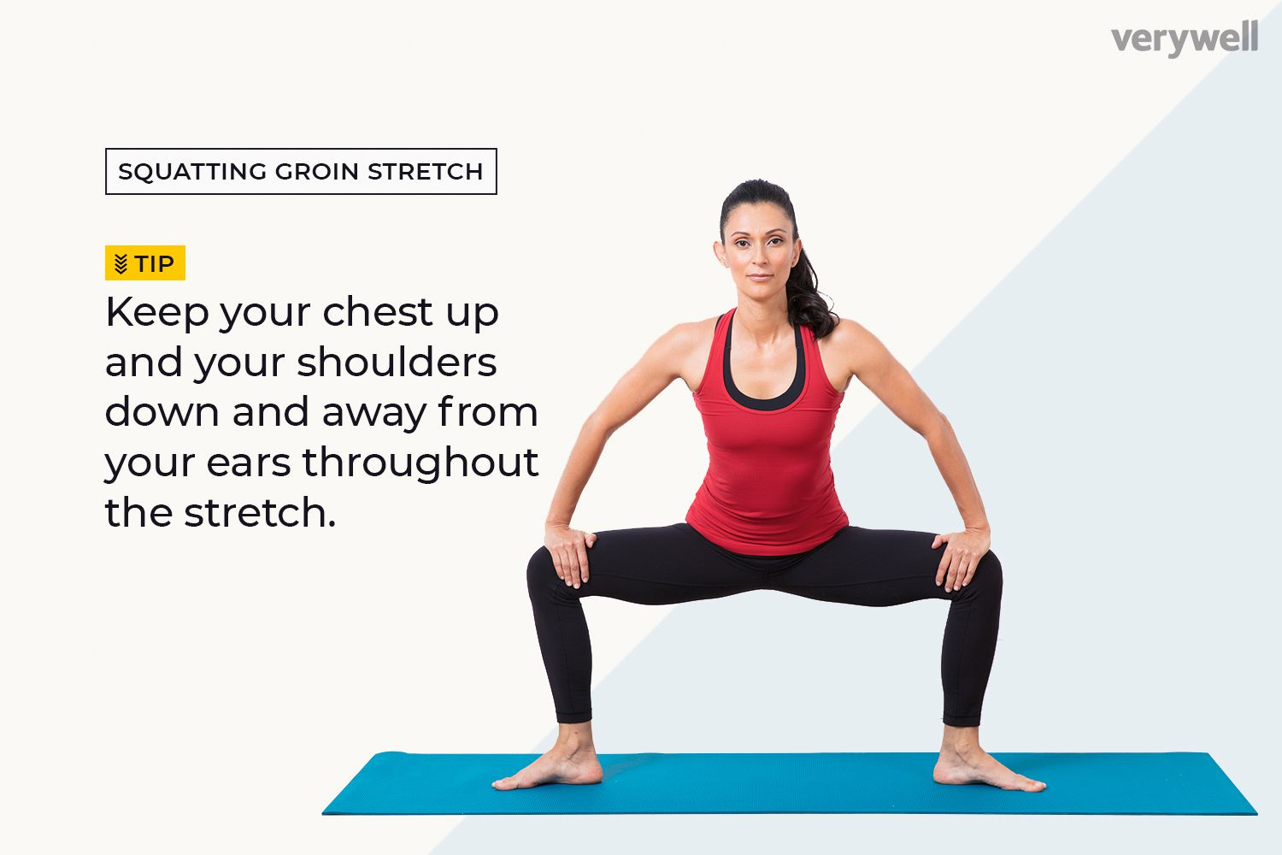
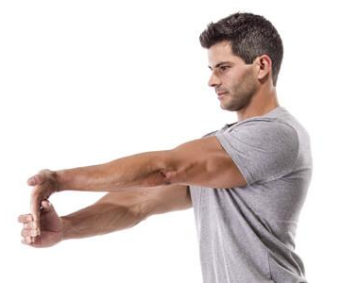
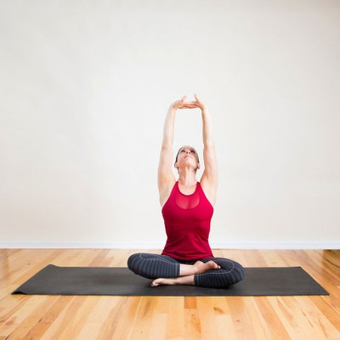
Contact Information
Fitness Specialist
Hannah LeBlanc
Hleblanc2@une.edu
508-23-9865

